ANCIENT ORDER OF HIBERNIANS
NEW YORK STATE BOARD EXPENSE REPORT
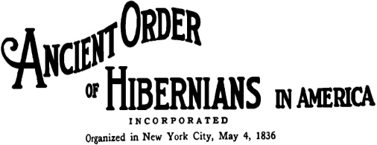
John J. Manning
New York State Secretary
204-10 9th Avenue
Breezy Point, NY 11697
OFFICERS NAME: ___________________________________________________________ DATE: __________________________  ADDRESS: ________________________________________________________ TITLE: ___________________________________  CITY: ______________________________________________ STATE: __________________________ ZIP CODE: ___________ | PAY PERIOD: _______________________ VOUCHER# ______________  FROM: __________________________________________  TO: ______________________________________________

DATE | DESCRIPTION | MILEAGE | LODGING | MAILING | PHONE | OTHER | TOTAL
SUB TOTAL
SUBTRACT ADVANCES
TOTAL
APPROVED BY: ________________________________________ SIGNATURE: _________________________________________________

NOTES: CURRENT MILEAGE REIMBURSEMENT IS $.45
ALL RECEIPTS MUST ACCOMPANY THIS EXPENSE REPORT

